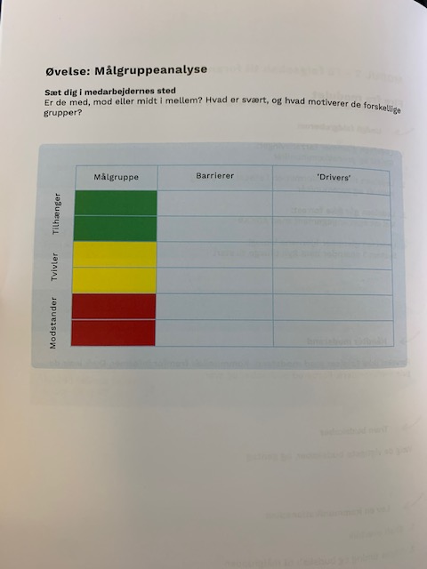

|  |  |  |
| --- | --- | --- |
| **Målgruppe** | **Barrierer** | **Drivers** |
|  |  |  |
|  |  |  |
|  |  |  |
|  |  |  |
|  |  |  |
|  |  |  |